GENERAL PLAN

for

HUNTSVILLE TOWN, UTAH

The Utah State law requires every community to adopt a general plan that states the present and future needs of a town and plans for the growth and development on the lands within that town. This general plan outlines the objectives selected for guiding Huntsville Town’s future development. In this regard, it reflects the present and predicted future needs and desires of the residents of Huntsville as expressed in a comprehensive survey in regard to the community’s growth and development of its land.

This plan is organized to:

- State a Town vision statement,

- Break that vision statement into objectives,

- Describe the current status of Huntsville Town,

- State the general approach selected to meet the objectives.

December 2022

1. HUNTSVILLE TOWN VISION STATEMENT 3
2. GENERAL PLAN OBJECTIVES 4
3. CURRENT STATUS OF HUNTSVILLE TOWN 5
3.1 Physical Description 5
3.2 Current and Proposed Land Use in Huntsville Town Boundaries 6
3.2.1 Residential 6
3.2.2 Commercial 7
3.2.3 Agriculture and Open Space 8
3.2.4 Institutional, Parks and Recreation 8
3.2.5 Roads 8
3.2.6 Reservoir and Wetland 9
3.2.7 Shoreline 9
3.2.8 Cemetery 9
3.2.9 Landfill 9
3.2.10 Water Treatment Plant 9
3.3 Present Zoning Regulations 9
3.4 Community Services 10
3.4.1 Transportation 10
3.4.2 Public Safety 11
3.4.3 Public Utilities 12
3.5 Environment 13
3.5.1 Soils 13
3.5.2 Climate 15
3.5.3 Sensitive Areas 15
3.6 Financial Condition 16
4. APPROACH TO MEETING GENERAL PLAN OBJECTIVES 18
4.1 Managing and Shaping Growth via Land Use Planning 18
4.1.1 Land Currently Qualifying for Annexation 18
4.1.2 Three Critical Locations That Will Define the Town’s Future Character 19
4.1.3. Annexation Proclamation Boundary 19
4.1.4 Specific Development Plan Zoning 20
4.2 Wise Management of our Natural Resources 20
4.2.1 Undeveloped Land 20
4.2.2 Trails 20
4.3 Increasing Community Involvement of Residents 20
4.4 Optimizing the Quality of Public Facilities and Services 21
4.4.1 Sewage 21

1. HUNTSVILLE TOWN VISION STATEMENT

Huntsville Town is a small, semi-rural town located in the Ogden Valley of the State of Utah. With improved transportation access, and the rapid growth of Northern Utah, the entire Ogden Valley is experiencing its own rapid growth. This growth is affecting the demographics and lifestyle of the Ogden Valley. While it is impossible to remain a town undergoing no changes, the citizens of Huntsville Town desire to grow in a planned and orderly manner that strives to maintain its’ unique character. The Town’s architecture is a blend of everything from original pioneer to large, modern home styles. The Town’s recent growth reflects the benefits and desirability of life in Ogden Valley with the emergence of large vacation homes and the rapid escalation of the average home price. These results are changing the Valley’s demographics to that of an older, higher income population (median age in 2020 is 48 years), with many of the newcomers possessing different viewpoints than long term residents on some issues.

The most striking feature of the Town is generally considered to be the visual perspective given via the large lots, deep house setbacks. and no curb and gutter, which combined with numerous trees and varieties of vegetation, imparts a quiet village atmosphere. The small, quaint downtown, large central park and surrounding mountain vistas provide the feelings that come from a spacious, comfortable, western country living environment. The Town’s character has been deeply influenced by the pioneer spirit, tolerance for and support of individual rights and sense of working together for the common good. It is not uncommon to see people on horseback on the streets, or to spot migrating birds or even an occasional deer or moose. The Town was originally laid out around a farming/agricultural grid format, with large lots, wide streets, and alleyways. It recognizes the shortage and escalating cost of housing ownership these features entail; but in order to maintain the lifestyle that has made the Town so livable and popular, the Town desires to continue maintaining the current regulations of a single family on a lot and no overnight rentals. The Town recognizes this will place burdens on some residents, but believes it is an unfortunate result of growth that must be accepted to maintain the desired lifestyle.

Therefore, the primary theme of the Vision Statement is to preserve as much of this semi-rural character of Huntsville as possible in the coming years. A resident survey result emphasized that this is the essence of Huntsville Town and that residents want to preserve this character.

Vision Statement for Huntsville Town

Huntsville Town residents enjoy a low population density, outdoor influenced, mountain country lifestyle conducive to raising families and fostering positive community spirit. Huntsville Town residents realize that growth is taking place all through Ogden Valley and welcome the diversity that new residents offer the Town. The residents are desirous of maintaining our high-quality lifestyle by managing and shaping our future growth via ordinances that encourage and preserve this lifestyle.

2. GENERAL PLAN OBJECTIVES

In order to enact the goals of the vision statement in Huntsville Town, its main components have been converted into objectives for this General Plan. While no plan that will satisfy the desires of every resident on every issue, recommendations herein were established to attempt to follow a majority consensus where one has been expressed via the Town survey which is on file at the Town Hall and prevalent concerns and comments from numerous Town meetings. Many residents share an opinion that reflects a desire for very little government control over what transpires in the Town. This General Plan attempts to compromise with that opinion while also reflecting the desires of other residents to enact governmental actions to preserve the quality of life in the Town.

When appropriate, this plan is harmonious with the overall General Plan for Ogden Valley prepared for and approved by the Weber County Commissioners. This General Plan is not so detailed that it stands alone, rather it provides a written statement of the theme/goals to guide decision making and ordinances through the upcoming years.

Overall Objectives for the Huntsville Town General Plan

1) Managing and shaping growth via land use planning

- Wise management of our natural resources

3) Increasing community involvement of residents

- Optimizing the quality of our public facilities and services

3. CURRENT STATUS OF HUNTSVILLE TOWN

3.1 Physical Description

Huntsville Town is a small community located in the southern part of Ogden Valley, twelve miles east of Ogden City near the head of Ogden Canyon. It is the only incorporated community in Ogden Valley, which offers the residents more direct control over what happens in their immediate surroundings. Two unincorporated communities, Liberty and Eden are located in the north and central regions of the Valley. Most of the Valley’s open land is used as pasture; land that is farmed is mostly irrigated fields of alfalfa or small grains. The Town lies on a mostly level terrace on the Eastern Shore of Pineview Reservoir, at an elevation of nearly 5,000 feet. There is a small peninsula jutting into the reservoir on the western edge of town, which includes the town cemetery, several very popular swimming beaches, and boat launching ramps. The U.S. Forest Service administers the beaches and shoreline as a fee area, subcontracting the operation of concessions and boat launching.

The incorporated area of Huntsville Town is primarily west of State Route 39, a designated scenic highway passing through Ogden Canyon, running south of Pineview Reservoir, turning north and heading east of Huntsville Town until it intersects with County Road 166 where it turns east again and heads to Monte Cristo and Woodruff in Rich County. County Road 166 follows the northern half of Pineview Reservoir and connects with Eden and the North Ogden Pass Road. The intersection of State Route 39 and County Road 166 is one of the busiest in the entire valley. There are only two streets that access the Town, both coming off the north– south running portion of State Route 39, which currently forms a large portion of the eastern Town boundary. All traffic entering or leaving town uses one of these two streets, both which are very busy during the summer season. The Town’s streets are paved, but alleys running north- south midway through some of the blocks are not. All streets and alleys are owned and maintained by the Town. To the north, south and east of State Route 39 lies unincorporated Weber County land. To the south is a steep escarpment of about 40 feet, portions of it that are within the 100-year flood plain of the South Fork of the Ogden River. An additional connector road to Ogden Valley is State Route 167 commonly referred to as Trapper’s Loop Highway that winds over the mountains to the south and connects the Valley with Mountain Green and Interstate 84 in Morgan County.

Weber County’s population was 268,369 in July 2022, with a growth rate of nearly 1% per year. According to the U.S. Census, Huntsville Town’s population was 553 in 1970, 557 in 1980, 541 in 1990, 649 in 2000, 608 in 2010 and 645 in 2020. As of the date of this document, there are approximately 350 dwelling units in Huntsville Town, with approximately 327 occupied by year-round residents. At this point, the Town is continuing to grow at a slow pace due to a shortage of moderate-cost vacant lots, there being few remaining building lots available in Town without resorting to subdividing. Should Huntsville’s population exceed 1000, Utah State law would require a transition to a Class 5 city, which would require a new form of municipal government.

3.2 Current and Proposed Land Use in Huntsville Town Boundaries

Huntsville Town currently has nine classes of zoned land use: 1) Residential (R-1), 2) Commercial (C-1), 3) Commercial Resort (CR-1), 4) Agricultural (A-3), 5) Park (P), 6) Shoreline (S), 7) Open Space, 8) Flood Plain (FP), and 9) Recreational (RC). Figure One is a zoning map of the Town that shows currently only R-1, C-1, AV-3, S-1 and CR-1 zones exist. The potential for a C-2 zone is being considered to allow for uses in certain areas that are not allowed in C-1. Using a Geographic Information System (GSI) and a base map provided by Weber County Planning Department, the following acreage of various land uses were estimated:

Acres Per Land Use

Residential 259 acres
Commercial 13 acres
Agriculture/ Open Space 134 acres
Institutional and Parks/Recreation 24 acres
Roads 111 acres
Shoreline 12 acres
Reservoir/Wetland 46 acres
Culinary waterworks property 3 acres
Ogden Boat Club property 7.6 acres
Cemetery 9 acres

Total 618.6 acres in Town boundaries

Water treatment plant and storage reservoir 1.3 acres
Landfill 40 acres

Total: 41.3 acres additional land owned by Town

3.2.1 Residential

Although residential is by far the largest category of land use, it comprises slightly less than half of the total area (47%). The residential areas are zoned R-1, with a minimum lot requirement of ¾ acre, which dates back to the original Town survey. The large lots include features such as gardens, pastures, barns, corrals and other farm out buildings. Multifamily dwellings or multiple dwellings are not allowed on a single lot. In compliance with State law, the Town allows a residence to establish an Internal Accessory Dwelling Unit (IADU) with certain restrictions. The Town does not allow for short term rentals, e.g., Air B&B, nightly rental, etc. in the R-1 and A-3 zones due to the impact such accommodations can have on the tranquility of a neighborhood. There are a few smaller lots that historically exist and are grandfathered to allow residential use, but if existing structures on these lots are replaced or remodeled, the new construction must comply with current building ordinances. The Town maintains a property database that lists all properties in town, the legal owner, and if any known issues i.e., boundary
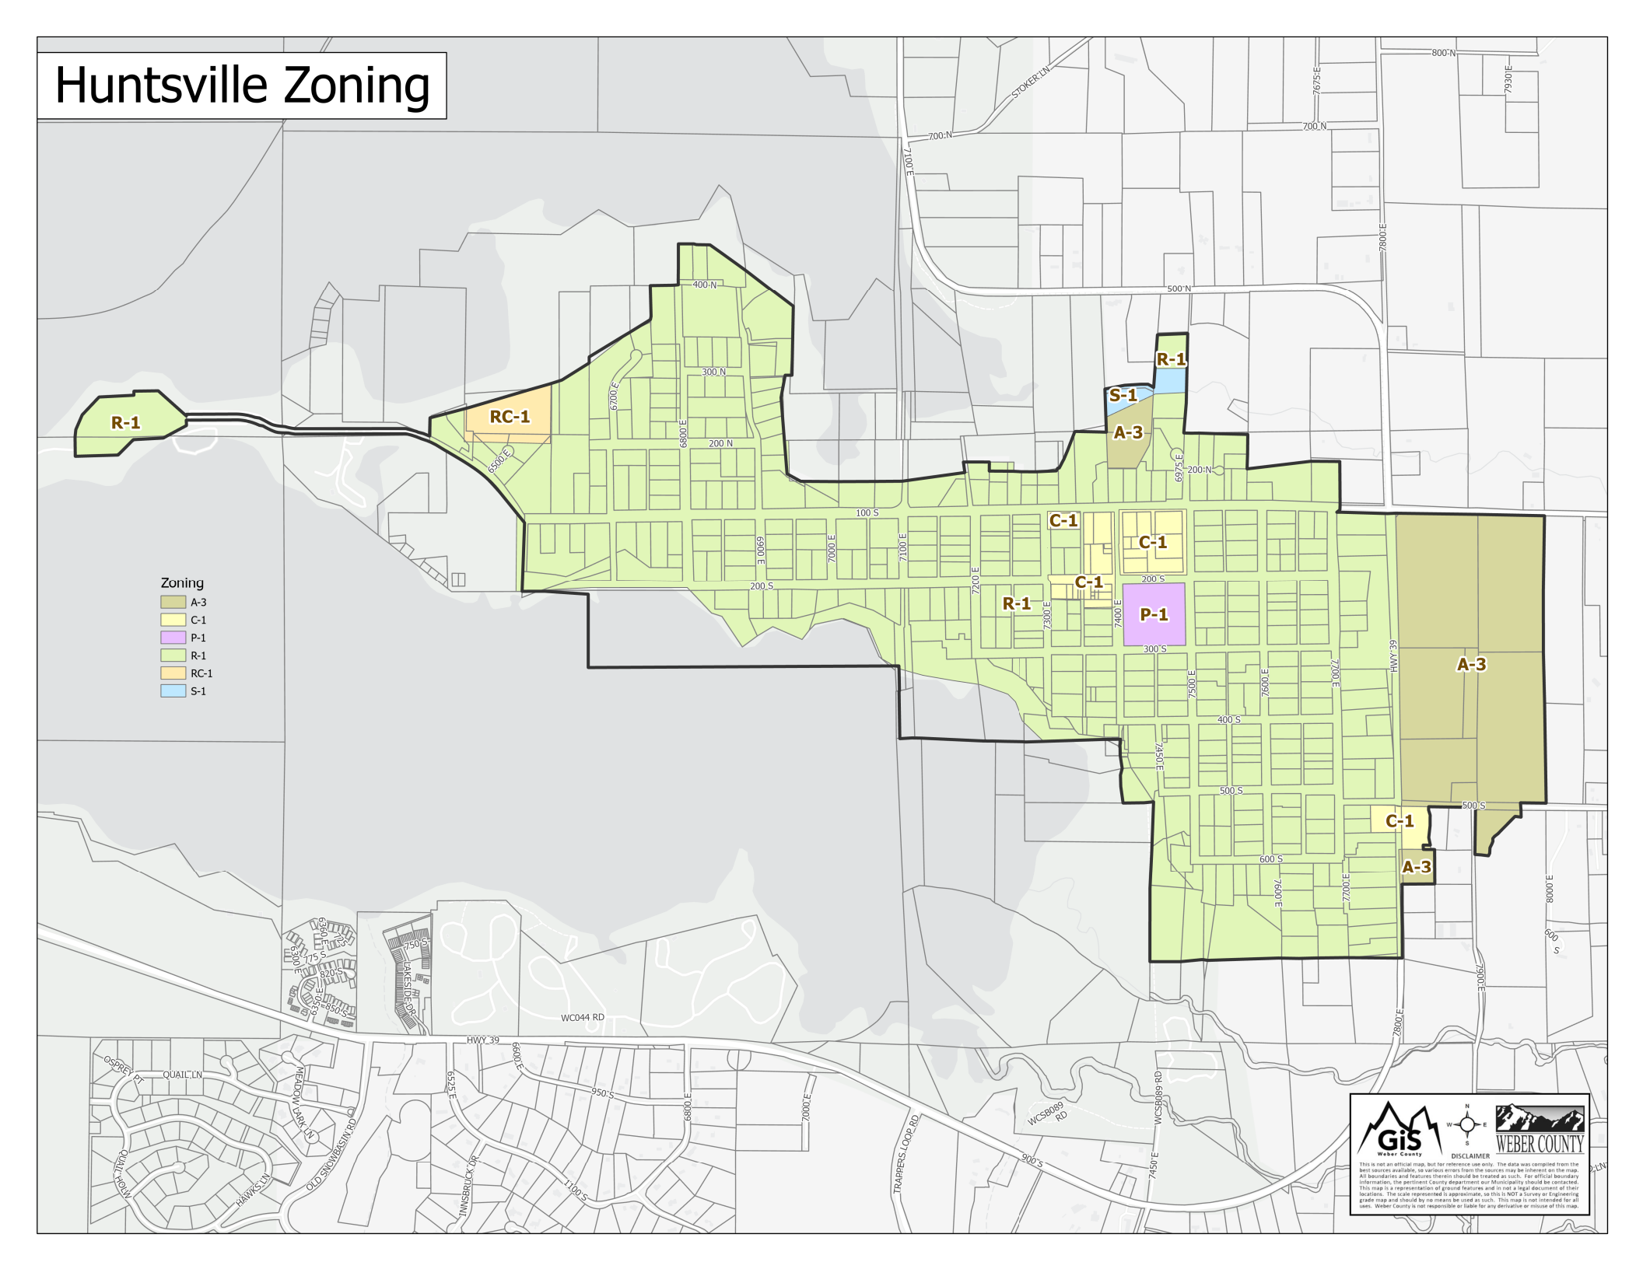

Figure One – Huntsville Town Zoning

disputes, non-conformances, etc. exist on the property. This information is available to the public via the Town Clerk. The residential area includes two buildings listed on the State Register of Historic buildings. They are the birthplace and home of David O. McKay, former President and Prophet of the Church of Jesus Christ of Latter-Day Saints, located at the corner of 200 South and 7600 East and the “Valley House” at 200 South and 7318 East, now a bed and breakfast inn.

3.2.2 Commercial

Commercial zones are located in two areas, the traditional center of town and land along the southeastern corner of Town. The traditional town center is small (8.5 acres) and provides the Town with a small amount of property and sales tax revenue. This area includes several small stores, the well-known Shooting Star Saloon, a reception hall, a small restaurant, two small Town-owned buildings, a storage barn, and the Compass Rose Lodge. The southeastern commercial area on the east side of Town houses the South Fork Village; the US Post Office, the American Legion, and a parcel due north of the post office that was rezoned to C-1 and rezoned back to R-1 in 2019. The area may be considered for a rezoning back to C-1 in the future. A zone C-2 is under consideration that would be for open land currently outside of town, primarily along Highway 39, to offer greater leeway than what is allowed in the current C-1 zoning. However, major commercial development will not be encouraged.

3.2.3 Agriculture and Open Space

Huntsville originated as a Latter-day Saint agricultural village where the residents lived in town and farmed the surrounding area. Agriculturally available space within the Town boundaries is relatively small (approximately 134 acres), currently composed of undeveloped R-1 and A-3 lots. These areas are mostly used for light agriculture purposes such as gardening, grazing, or maintaining small animals.

3.2.4 Institutional, Parks and Recreation

Institutional use (24 acres) refers to public and government buildings, facilities or land (e.g., the library, church, post office, town hall, town maintenance building, etc.), and a community park encompassing a square block bounded by 200 to 300 South and 7400 to 7500 East and an approximately .8 acre playing field in the SE corner of the block due north of the park. Pickle ball courts were built in 2018 in this area. There is also an area zoned RC for private recreation owned by the Ogden Boat Club.

3.2.5 Roads

Roads, street right of ways, and alleys comprise the second largest land use in the community, 111 acres (21%). The width for the combination of street and right of way is generally 99 feet, with some 66-foot secondary roads. The width combined with the required building setbacks, increases the overall setback of homes, adding to the open feeling. The width for the paved portion of roads itself varies from 18 to 20 feet depending on the location in town. For example, the paved portion of 100 South (First Street) is wider than the rest of the town’s streets because it is the primary road to Pineview Reservoir from State Route 39 and sees heavy use. Many residents use the unpaved portion of the right of way (the verge) as part of their yards. The alleys were originally created to give access to barns, corrals, and outbuildings, by providing a 33-foot-wide easement where animals could be driven from home to pasture without using the main streets. Today, they are used by some residents for property access and by the Town and Huntsville Water Works Corporation for utilities (underground culinary and secondary water lines). The Town intends to maintain the streets as they are, with the current width requirements, and without curb and gutter, to maintain the rural feel.

3.2.6 Reservoir and Wetland

The northern-most area of the Town, comprising 45 acres (8.5%) maintains the overflow volume for Pineview Reservoir. The water level varies from season to season and year to year, creating a wetland area during times of high water.

3.2.7 Shoreline

A small portion of land around Huntsville is shoreline along Pineview Reservoir. Portions of this shoreline attract very large crowds during the summer months.

3.2.8 Cemetery

Huntsville’s cemetery consists of 9 acres and is located at the tip of the peninsula, which juts out into the reservoir.

3.2.9 Landfill

The Town owns 40 acres of land approximately 4 miles east of Town that straddles the South Fork of the Ogden River. A portion on the north side of the river is used for a green waste landfill and 11 acres on the south side of the river is potential buildable land, although it is in the 100-year flood plain. The landfill has been utilized as a licensed Class 4 landfill, which allows dumping yard waste and some approved demolition materials. Currently Town ordinances allow only yard waste. The soil/rock displaced from the holes dug at the landfill have been used as backfill and road base material in Town projects. Yard waste burns are scheduled once a year.

3.2.10 Water Treatment Plant

The Town added a water treatment plant to its culinary water system in 2000, with a 1,000,000- gallon storage reservoir. The plant uses inline filtration and chlorine injection to provide excellent quality water to the community and a few customers outside of Town that purchase Town water in an exchange arrangement for easements necessary to run piping from the treatment plant to the Town.

3.3 Present Zoning Regulations

Current land usage in Huntsville Town consists of property zoned in three of the nine zones, Residential, Commercial and Recreational. As mentioned in paragraph 3.2. above, with the exception of three small commercial zones, small A-3 and S-1 zones and one CR-1 commercial resort zone, the entire town is zoned R-1. The Town land use ordinances contain additional zones that allow for flexibility with any land that might be annexed by the town. The R-1 (3/4-acre lot minimum) zone requirements reflect the western attitude of allowing for independence and flexibility with the use of private property. The commercial areas are zoned C-1. The C-1 ordinance regulates business types, signage, and lot use issues under a conditional use arrangement. A C-2 zone is under consideration to allow further controlling what types of commercial enterprises can be allowed in commercial zones, especially when surrounded by residential zoning. The A-3 zone includes the possibility of cluster housing or three-acre residential lot development to provide for additional spacing options on large tracts of land. Figure One is the current zoning map that also identifies the immediately adjacent areas to Huntsville Town that might possibly be annexed in the future. It reflects the recently annexed section of land immediately east of Highway 39.

No site construction is allowed until land use and building permits are approved. The Building Official cannot issue a building permit if a Land Use permit hasn’t been obtained first or if the proposed structure does not conform to the Town ordinances. A certificate of occupancy must be applied for along with an application for a building permit. A Building Inspector approved final inspection is required before a house may be occupied.

3.4 Community Services

3.4.1 Transportation

Traffic counts on local roads show a steady increase over the past decade in the number of vehicles using the roads and that Huntsville Town residents account for only a small percentage of daily traffic in the vicinity of the Town. At busy times during the summer season, the congestion at the intersections of Highway 39 and First and Fifth South is extreme. Traffic within the town boundaries has seen a similar increase, with some problems resulting due to speeding in residential areas.

a. Road Maintenance

Huntsville Town obtains its road maintenance monies from the State Class B and Class C Road Funds. This State B & C Fund is maintained by taxes collected from gasoline sales and is distributed by a formula that divides monies among all roads in the state. Different categories of roads receive a specified number of points, which determines how much money can be obtained from the fund. This money must be used for buying road equipment, road materials, maintenance, and snow removal expenses, etc. Huntsville Town has received grant or low-cost loan monies in the past to help with its road maintenance. funds. As the roads age and the traffic increases, roads have become the largest budget item in the Huntsville Town budget and future projections are there will be a shortage of money to maintain the roads in good condition.

In 1998, the Utah Technology Transfer Center at Utah State University conducted a survey and presented the Town a written report recommending several possible road maintenance plan options. Several of the recommendations were adopted by the Huntsville Town Council, thereby forming a basic road maintenance plan. With the consistently increasing costs of road maintenance and the changes that the roads have undergone since 1998, the Town needs to review the plan and adopt a revised/new Master Road Plan. The most significant road maintenance is required on First Street which sees large volumes of traffic in the warmer months since the addition of a boat ramp established Cemetery Point as the gateway to the Pineview Reservoir recreational area. After lengthy negotiations with the Cemetery Point concessionaire, Huntsville Town receives a portion of the entrance fees to help with the maintenance of First Street.

Alleyways, which are Town property, are a persistent problem. There are 23 alleyways in Town which a recent survey found 4 blocked with resident’s belongings or illegally fenced off. The general consensus is for the alleys to be open and remain Town property, which will require some enforcement actions to accomplish.

b. Pedestrian needs

Walking is a popular pastime in Town and poses a conflict at times due to unleashed dogs (see Animal Control). There are no sidewalks in Town and streets are often narrower and very slick in the wintertime.

c. Parking

There are no Town parking lots. The LDS church building in the center of town and the streets around the Town Park are used to park vehicles during large events, such as the Fourth of July. The Town has considered using a lot it owns across the street to the east of the Weber County Library for additional parking should the near arise in the future. The Town has an ordinance that does not allow camping in vehicles overnight on public streets. During the summer season, visitors to the reservoir often park on Town streets and walk to gain access to the water or the facilities at Cemetery Point to avoid paying an entrance fee. This creates issues with trash, sanitation, vandalism, trespassing, and traffic congestion. The Town has passed a parking ordinance and now posts ‘No Parking” signs around town that don’t allow for reservoir visitor parking during the busy reservoir usage season.

3.4.2 Public Safety
- Law Enforcement
Huntsville contracts with the Weber County Sheriff’s Office for police protection. The Weber County Sheriff offers a wide range of resources, especially backup officers for the occasional large crowds experienced during summer (May through September) recreational activities. Crime has traditionally been non-violent and infrequent, but with the increase in expensive, often vacant homes in the Valley, burglary has increased. The Town has occasionally contracted a part-time Ordinance Control Officer to aid in dealing with ordinance enforcement, primarily nuisance, animal control and land use issues. A Volunteer in Policing Program (VIPS) supports the Weber County Sheriff’s Office by training volunteers to help patrol Ogden Valley.
b. Fire
Huntsville Town chose to be annexed into the Weber Fire District and contracts with them for emergency services. A new fire station recently opened several blocks east of Town. The response time to Huntsville Town from this station is approximately 1-2 minutes, while crews traveling from Ogden City take approximately 15-20 minutes depending on urgency and location of the emergency. Some Town alleyways are illegally blocked to an extent that they would prevent fire vehicles from getting close to buildings.

c. Animal Control.
At the present time, Huntsville Town employs Weber County Animal Control to handle domestic animal control concerns within the Town, supplemented by an Ordinance Control Officer. Huntsville Town has a dog leash requirement in its Animal Control ordinance that prohibits allowing dogs to roam freely, but occasional encounters with unleashed dogs occur.
d. Lighting
The Town has a lighting ordinance that specifies the type, size, and location of lighting with the intent of protecting open (dark) skies. Overhead streetlights are located at numerous intersections, but there are no traffic lights in Town. The Town supports the Dark Skies movement, and the lighting ordnance requires certain restrictions on outdoor lighting in support of reducing light pollution.
e. Signing
The Town has a sign ordinance that specifies the use, type, size, quantity, and location of signs.

3.4.3 Public Utilities
a. Culinary Water Supply
Currently Huntsville Town receives its culinary water supply from three springs, flowing out of what is known as Bennett Springs, located on unincorporated property southeast of Town previously owned by the Abbey of Our Holy Trinity. Huntsville Town owns water rights out of two of the springs and shares the rights to the third spring with the current property owners. The Town also owns a well near the culinary water plant and Hawkins Springs that are currently not in use. The Town has a modern water treatment plant housing three styles of filters (media, bag, and cartridge), which allow for filtering down to the one-micron level. The plant includes room for more filtering units in the event of future increased demand for water. After the filtration process, the water is treated with chlorine and pumped to a one-million-gallon storage tank. The overall system is capable of handling additional residences, allowing for modest future growth. If substantial growth, e.g., a major sub-division, were to take place, upgraded facilities and distribution infrastructure would be required. In the 2000s, follow-on CBD grants allowed for several new water lines in Town to be installed, replacing, and upgrading old lines and fire hydrants. In 2015, the Town contracted for a Hydrogeological Evaluation and Assessment of Groundwater Development Potential. It identified areas where a second source of culinary might be achievable. 2018 CBDG and CIB grants allowed using this information in drilling for a Utah State mandated secondary water source. On April 9, 2018, the Town entered into an agreement with Huntsville Abbey Farm, LLC, the owner of the former Monastery farm, that allowed the Town to drill a culinary water well on Abbey property. Under the terms of the agreement, the Town is only allowed to withdraw water from the well during times of drought and if the total discharge of all the Town’s spring sources falls below 150 gallons per minute. The Town is limited to a maximum withdrawal rate of 100 gpm and Huntsville Abbey Farm owns all the well’s capacity beyond the first 100 gpm. After one unsuccessful attempt, a good production well was developed that is under testing for State approval as a permanent source.
b. Irrigation Water Supply
The Town receives irrigation water from a holding reservoir east of Town fed by the South Fork of the Ogden River. An underground delivery system supplies to water to the Town. The system is owned by the Huntsville Waterworks Corporation, composed primarily of Town residents, but independent of the Town government. Low pressure issues exist on the far west side of Town during busy watering times. Recent drought conditions have not impacted the supply capabilities, but there is a possibility of rationing in the future. Residents are requested to follow a voluntary schedule of days they can water. Metering may become a state requirement and the Town could be forced to comply.
c. Power
The Town obtains electrical power from Rocky Mountain Power. Natural gas is available in Town from a natural gas feeder line paralleling the Trapper’s Loop Highway from Mountain Green. A gas regulator station is located east of State Route 39 near the north side of the American Legion building, reducing the gas pressure to 50 psi, supplying Interim High Pressure (IHP) lines routed throughout the town. At the edge of each property, the IHP line is tapped and fitted to a service line (1/2” to ¾” diameter at 15 psi, depending on household needs) which is then connected to a gas meter. The lines within the house or structure are reduced down to flow with four ounces of pressure.
d. Refuse
Huntsville Town contracts refuse disposal to a private company, which picks up containers at each household and exports the refuse to the Weber County Transfer Station who delivers it to the East Carbon County Landfill. The Town also contracts with the same company for a second container provided for recyclable waste materials.
e. Sewage
All homes in Town are currently on individual septic systems. Due to continuing Valley growth, especially around the perimeter of Pineview Reservoir, the State of Utah has been promoting a Valley-wide sewer system to hopefully mitigate a declining Pineview Reservoir water quality. The Ogden Valley General Plan points out that Weber County is seriously encouraging a Valley-wide sewer district to be instituted in the future. The Huntsville Town Council joined Weber County in contracting for a sewer feasibility study that provided recommendations and a Wastewater Capital Facilities Plan in 2012. After review of the benefits vs. the impacts to Town residents, the Council decided to continue using the current septic systems in the foreseeable future.

3.5 Environment

3.5.1 Soils

Huntsville Town contains three major soil types as defined by the US Soil conservation Service-Utaba cobbly loam, warm (UbA), Phoebe fine sandy loam (PhA); and Parley’s loam, high rainfall (PaA). Soils are important to the future development of Huntsville because of their permeability or absorption rate, surface runoff, rate of erosion, and depth of the soil to the water table. The Utaba cobbly loam, warm is a soil type formed by alluvium from stream flooding. It is characterized by the large rock fragments found on or close to the surface. Flooding on Utaba soils occurs mostly during late winter and spring. Most of the land is abandoned or fallow cropland, which can support fields of alfalfa and small grains with the use of commercial fertilizers and manure. Flooding potential has hampered urban and recreational development of this soil, even though the threat for flooding has been greatly reduced with the introduction of Pineview and Causey reservoirs. In the town of Huntsville, the Utaba soils are found mostly along the north boundary and along the northern shore of the peninsula leading to the cemetery. The water table is at a depth greater than six feet and is good for septic tanks unless flooded. There is also the possibility of ground water contamination.

The Phoebe fine sandy loam is found in the eastern half of Huntsville, bordered on the north by the Utaba soils and to south by a steep escarpment with the South Fork flood plain below. It is also found in the northwest part of town near the reservoir. This soil is good for homesites and other development; however, problems with septic tank drainage may occur during flooding, and contamination of ground water in such instances is likely.

Parley’s loam, high rainfall is a soil that has a slow permeability and a slow runoff because it is mostly flat, although some of the soil must be leveled to insure proper distribution of irrigation water. It lies mainly on the western side of the town including most of the peninsula and the cemetery. While flooding is not an immediate threat because of its location above the South Fork floodplain, the slow absorption of water may cause septic tank problems. Contamination of ground water is also possible with the use of cesspools for sewage.

Immediately to the east of State Highway 39 the soils are mostly Eastcan loam (EaA), Canburn silt loam (Cb), and Crooked Creek silty clay loam (Ct). These soils have a slower permeability than the soils to the west, and also have a shallow depth to the water table, making them more susceptible to flooding. Of these three soils, the Eastcan loam has the best potential for building homes; however, it has a low load support, and septic tank problems can readily occur. Much of the Crooked Creek soil is classified as wetlands or wet meadows because the clay in the soil and lack of slope retards normal drainage. It occurs mostly to the northeast of the present town boundaries, close to Huntsville Spring Creek.

In the areas lying to the south of Huntsville Town are three very different soils: the Sunset loam (SwA), Nebeker clay loam (NrA), and the Ostler-Casey complex (OcG). The sunset loam is the floodplain of the south fork of the Ogden River and is rich in gravel and other sediments. While there is a possibility for future development, the high-water table makes flooding a potential problem, especially during the spring runoff. The high-water table also makes it difficult to have septic tank drainage, and cesspools may pollute ground water supplies. Much of this land is under consideration by the US Army Corps of Engineers for possible wetlands.

The Nebeker clay loam is found around the junction of State Routes 167 and 39 (Trapper’s Loop) near the south shore of Pineview Reservoir. While suitable for homesites, it is a clay soil and therefore slow absorption, and runoff poses a slight flooding hazard. Septic tanks can also pose a threat to water quality. The Ostler-Casey complex occurs along the foothills of the mountains along State Route 39 near the intersection with SR 167. Because it is a soil formed on the sides of mountains and foothills, it is susceptible of high erosion and slippage. Roads built in this area must conform to the low load capacity, and therefore high-density urban development is unlikely. Its location on the mountain makes it an excellent possibility for water storage; however, cesspools or septic tanks should not be used in this area.

3.5.2 Climate

Because of its location in a 4940 ft mountain valley, Huntsville’s climate is slightly different than that of Ogden City. Ogden Valley receives on average about 30 inches of precipitation a year, most of it as snow. During the spring and winter, cold mountain air frequently settles into the valley, creating a temperature inversion with temperatures that often dip well below zero. The coldest month is January with an average temperature of about 17 degrees Fahrenheit. Snow can occur anytime from September to early May, and heavy snowstorms have closed access to Ogden Canyon for several hours. Despite the cold winters, Huntsville does enjoy a warm summer. The frost-free season of approximately 110 days makes it difficult to grow temperature sensitive fruits and vegetables. July is the warmest month when the temperature averages 70 degrees.

a. Air Quality

The State of Utah Division of Air Quality is part of the Utah Department of Environmental Quality. Huntsville air quality must meet the standards set for Weber County, and the Federal government, which has not been a problem to date, although poor quality air from west of the Wasatch Mountains occasionally enters the Valley. Reduced use of wood as a primary source of winter heat has reduced the particulate emissions, which result. Since Huntsville residents register their cars with Weber County, they are required to pass vehicle exhaust emission standards.

Sensitive Areas

- Wetlands
Jurisdiction and management of wetlands are dependent upon the U.S. Army Corps of Engineers. Wetlands can become centers of controversy and therefore it is very important that the Corps of Engineers is contacted before development on any questionable land begins. The Corps has the right to condemn any structure or use that is not in accordance with wetland legislation. They also have the power to coordinate a mitigation plan with the property owner, e.g., replacing a wetlands spot by creating a similar wetlands area on another part of their property.

A small stream runs through pastureland in the northeast corner of the Town and eventually joins the Huntsville Spring Creek on its way to Pineview Reservoir. Since the area there is very flat and is inundated with water most of the year, this pasture classifies as a wetland. The North Branch of the South Fork of the Ogden River, which lies in a floodplain south of Town, also might be classified as wetland. If annexation of either area was to occur, care must be taken to resolve the wetland issues. The recently annexed land to the east of Highway 39 contains wetland that is under development and must be reviewed and adjudicated by the Corps.
- Floodplain
The only areas currently identified that are within a Federally determined floodplain are located south of Town where the South Forks of the Ogden River enter Pineview Reservoir. This floodplain and the associated shoreline areas are classified Zone A (probable 100-year flood occurrence) with no houses or development allowed without approved mitigative measures in place.
- Slope

Most of Huntsville Town lies within the 0-8% slope classification, which is suitable for all forms of development. Proposed annexation to the east of Town would also fall into this category. Development on the escarpment dropping off to the South Fork flood plain and on the floodplain should be approached carefully.

- Erosion

Because the townsite is on a flat lakebed of ancient Lake Bonneville, there is very little slope to the land and little erosion. The exception is near the southern boundary of the Town, where an escarpment drops approximately 40 feet to the South Fork flood plain. The slope is quite well vegetated and does not appear to have serious continuing erosion problems.

3.6 Financial Condition
The Town has a history of sound fiscal responsibility, consistently maintaining a balanced budget in the range of $540,000/yr. The Town has no large sources of revenue, the largest ongoing amounts coming from intergovernmental sources reflecting a proportional distribution of monies collected by the state and county in property, gasoline, and sales taxes. Beyond these revenues are charges for Town services such as refuge collection and culinary water. Larger projects, such as a new Town Hall are paid for with grants, sale of the old Town Hall and Town owned properties, and loans. The following are the categories of current revenue sources for the town:

a. Taxes – property, franchise, sales, liquor, and gas.

- Rental income from Town owned property (two small buildings in the town center, landfill area).

- User/permit fees (park, building, cemetery, portion of boat ramp/beach fees). It’s important for the Town to charge enough for the use of the park to cover all costs to the Town, including a fee for the inconvenience, and then a profit on top of that. Each year there are many requests for use of the park for special events. The park is a valuable asset and outside users represent a depreciation of this asset that needs to be accounted for in the fees.

d. Enterprise funds (water and refuge). These are handled in separate funds and used for capital improvements and future infrastructure maintenance. The funds are supported by the rates charged for culinary water and based on the actual cost to produce plus an allotment that goes towards growing these funds such that the adequate amount is available when needed.

e. Fines and penalties. The Huntsville Town council assigs fines and penalties via ordinance actions.

- Donations, grants, 4th of July, and Huntsville Utah Marathon. The marathon, which is a Valley-wide collaboration, has been a very successful endeavor and resulted in a significant revenue source for the Town. It was suspended due to the Covid pandemic, and it is undetermined if it will be continued in the future.

4. APPROACH TO MEETING GENERAL PLAN OBJECTIVES

4.1 Managing and Shaping Growth via Land Use Planning

The single most expressed desire from Town residents is conserving the small town, relaxed atmosphere. While it enjoys a good relationship with the Weber County Commissioners, Huntsville Town has little influence over how surrounding land in Weber County is developed. Residing within incorporated Huntsville Town offers residents the opportunity to play a greater role in how the/their property is developed. Based on results of a Town survey and experience with developers, the Town has explored annexing nearby land as a step in gaining greater control over the growth in its immediate vicinity. The Town desires to preserve its existing grid system lot layout as much as land conditions and topography allows to maintain the feel of the historic Town. However, the Town’s A-3 zoning allows for some clustering of houses to take advantage of/preserve the natural features of the land and to maintain some open space. Where it represents the preservation of natural resources or open space, the Town supports placing land into trusts such as the Ogden Valley Land Trust. No annexation petition will be accepted without first assessing the Town’s ability to deliver critical infrastructure (culinary water, traffic safety, road maintenance, etc.) currently provided to existing residents and ensuring the potential deficit of revenue vs. expense to the Town is not unreasonable. If the impacts required would be substantial enough in cost, the Town would levy impact fees on the developers of that land as a condition of the annexation approval. The Town does not own the secondary water system and being annexed does not have any bearing on whether a property can be hooked into the secondary irrigation system. Culinary water is not permitted for irrigation purposes. Property will be annexed into Town under its current zoning whenever possible. The Town ordinances have similar zones to Weber County but does not have a RE-20 (20,000 sq ft lot size) zone. Figure Two represents the vision Huntsville Town has for the areas immediately surrounding the current Town boundaries and the concerns/zoning considerations for these areas.

A major impact that could result from annexation is the State law requiring a town whose population exceeds 1000 to transition to a Class 5 city, which would require a new form of municipal government. This would require extensive planning, reorganization, hiring, costs, etc.

4.1.1 Land Currently Qualifying for Annexation

The land currently qualifying for annexation is immediately north, east, and south of Town bordering either side of State Route 39 which roughly circles the Town and represents the major transportation corridor for this end of the Valley. No development will be allowed that requires the main vehicular access off State Route 39 unless safety and traffic concerns are adequately addressed with the Utah Department of Transportation. A large tract (~72 acres) was recently annexed immediately east of Highway 39, bounded by Highway 39 on the north and 500 South on the south. The annexation also included the Weber County Fire station on 500 South. The developer who purchased the land is currently negotiating a development of large homes on 3+ acre lots with the Town Planning Commission/Town Council.

4.1.2 Three Critical Locations That Will Define the Town’s Future Character

4.1.2.1 Several pieces of Weber County property along the east side of Highway 39 to the immediate north and south of South Fork Village are currently zoned as A-3 and undeveloped (reference Figure One). With the building of the US Postal facility on the southwestern corner of the intersection of 500 South and Highway 39, this area was further established as one of two future hubs of the Town’s commercial development. This area has been identified by Weber County as a potential receiving zone for transferred development rights. The Town does not have an ordinance allowing transferring development rights. The Town is not in favor of a rezone to commercial and one long strip mall-type spread along Highway 39, rather believing that this land would best be developed with a mix of residential, commercial, and open spaces in park-type uses. The northern portion of land has been purchased, annexed and is under development for 3-arce residential lots, allowing for approximately 20 large homes.

4.1.2.2 The area immediately south of the current Town boundary and west of Highway 39 has been proposed to the Town for annexation and development in the past, although the current owners have stated they are not interested in development. This area contains areas zoned RE-20 and S-1 in Weber County and incorporates a FEMA-designated flood plain. Any development would require careful planning to accommodate the natural features that do not lend to easy development. Due to the increased infrastructure and management costs that would result on behalf of the Town, the Town has not annexed the land.

4.1.2.3 Huntsville Town will continue to encourage suitable public and commercial development in the historic commercial center of Town, with a goal of maintaining its unique character. The demolition of Valley Elementary School made a significant negative impact on this area. The Town was able to negotiate the purchase of this land and rezoned it C1. The northeast corner of 200 South and 7400 East was sold to a developer and now houses the Compass Rose Lodge and space for another building, which is planned for building in the near future. The building on the intersections northwest corner has been remodeled and is now the Huntsville Mercantile Reception Center. The Town recently completed a beautification project for all four corners of the intersection. The southeast corner of 100 South and 7400 East contains two Town-owned lots that the Town considered selling and is now considering one of several other potential uses for the property, with commercial, commercial-residential, or residential all being considered. A new Town Hall is planned for the property along 200 South east of the Compass Rose. The current Town Hall was sold, and the Town currently uses various buildings for offices and meetings.

4.1.3. Annexation Proclamation Boundary

The area that would be considered for annexation in the Huntsville Town Annexation Policy Plan is contained at the end of this section as Figure Two. Residents in unincorporated Ogden Valley are currently considering incorporation. Any land not within Huntsville's Annexation Proclamation Boundary could be part of this incorporation effort but would have to receive the approval of Huntsville Town. The Town is updating its’ Annexation Proclamation to include the area up to the intersection of Trappers Loop Road and Highway 39 due to the possibility of commercial development in that area, which the Town might want to include in its boundaries.

4.1.4 Specific Development Plan Zoning
An SDP overlay ordinance specifically for the C-1 zone was adopted to allow more flexibility in bringing about the goals and objectives of this General Plan in future developments. The regulations and development standards of an SDP overlay may vary from the standards of the C-1 zone, but only after a detailed review and approval of the Town government.

4.2 Wise Management of our Natural Resources

Huntsville Town recognizes that wildlife specific habitat, wetlands and open space are necessary to support the maintenance of the Valley’s wildlife species, which in turn enriches the quality of life in the Valley. Of primary concern are the impacts involving wetlands, water aquifers and floodplains.

4.2.1 Undeveloped Land
The Town recognizes there are natural sensitivities existing on much of the surrounding undeveloped land and feels it necessary to require appropriate sensitive land studies (e.g., wetland assessment, etc.) be conducted to evaluate the impacts of any rezoning or development prior to issuing building permits. Sensitive lands analyses must consider the impacts to both human and wildlife habitats. The Town has a Sensitive Lands ordinance and supports maintaining a cooperative relationship with the State Division of Wildlife Resources and Army Corp of Engineers to foster continuing a sustainable wetlands and wildlife populations.

4.2.2 Trails
Huntsville Town believes that trail systems support improved quality of life through better health
and enjoyment of our natural resources. The Town supports participation in groups promoting the development of trail systems throughout Ogden Valley. The Town received a RAMP grant and in cooperation with the Trails Foundation of Northern Utah, built a trailhead kiosk in the SE corner of the field just north of the Town park. The Town also added a restroom facility to the park playground in the NE corner of the park. The Pineview Loop trail now routes through Town including the kiosk as a trailhead/parking location and the Winter’s Grove trail on the southwest boundary of the Town.

4.3 Increasing Community Involvement of Residents
A broad range of skills exist within the Town’s citizenry. Huntsville Town encourages greater involvement of its citizenry in helping to achieve our mutual goals and supports efforts to foster community service, good will, spirit, etc. Many of the amenities that exist in Town would not have been possible without the gracious donation of citizen’s time and skills. The annual Fourth of July celebration is well known throughout Northern Utah as an example of a community that lives and plays together. The Huntsville Marathon has been a resounding success, involving many residents, and continues to be a perennial standout event. The Town supports the fostering of activities such as this that brings citizens together in a mutually beneficial manner but with some restrictions on the quantity and size of such events. Essential in this effort is communications to the populace and the Town is maintaining a website and email list for announcements regarding Town events, activities, etc. The Town also utilizes a newsletter in the water bill, and the local newspaper, the Ogden Valley News, for communications to the larger Ogden Valley populace.

4.4 Optimizing the Quality of Public Facilities and Services
Public facilities are important to the residents of Huntsville Town. The Town plans to maintain, improve and develop new facilities in a prudent manner and as budgets allow. The Town maintenance buildings west of the library were replaced with a new Maintenance building funded by a CBDG grant on the northeast corner of the former Valley Elementary school property purchased by the Town. The old maintenance facility was acquired by the Weber County Library System to use the land for enlarging their current facilities. The Town park continues to see frequent use and an investigation is underway to explore the possibility of running the power lines underground alongside the park to avoid having to cut trees for line clearance.

4.4.1 Sewage
The Ogden Valley General Plan identifies the possibility of a valley-wide sewage system in the future. The Huntsville Town Council recognized that prudent planning required a detailed definition of the issues and impacts involved. The Town Council, in coordination with the Weber County Commission, agreed to conducting a wastewater collection and treatment capital facilities study, completed in 2012. Due to the enormous impact on residents and indefinite benefits to water quality identified in the study results, the Town Council does not support building a Valley-wide sewage system at the present time. In 2022, separate Ogden Valley water and sewer studies funded by Weber Basin Water Conservancy District and Weber County Commissioners respectively, were conducted. The water study recommended no new wells be drilled in the Valley due to the existing water supply being unable to support more development and a Valley-wide culinary system be developed. The sewer study recommended a Valley-wide sewer system be built to reduce the pollution to ground water feeding Pineview Reservoir. Both studies identified significant negative impacts from further Valley growth to both the environment and costs to residents.

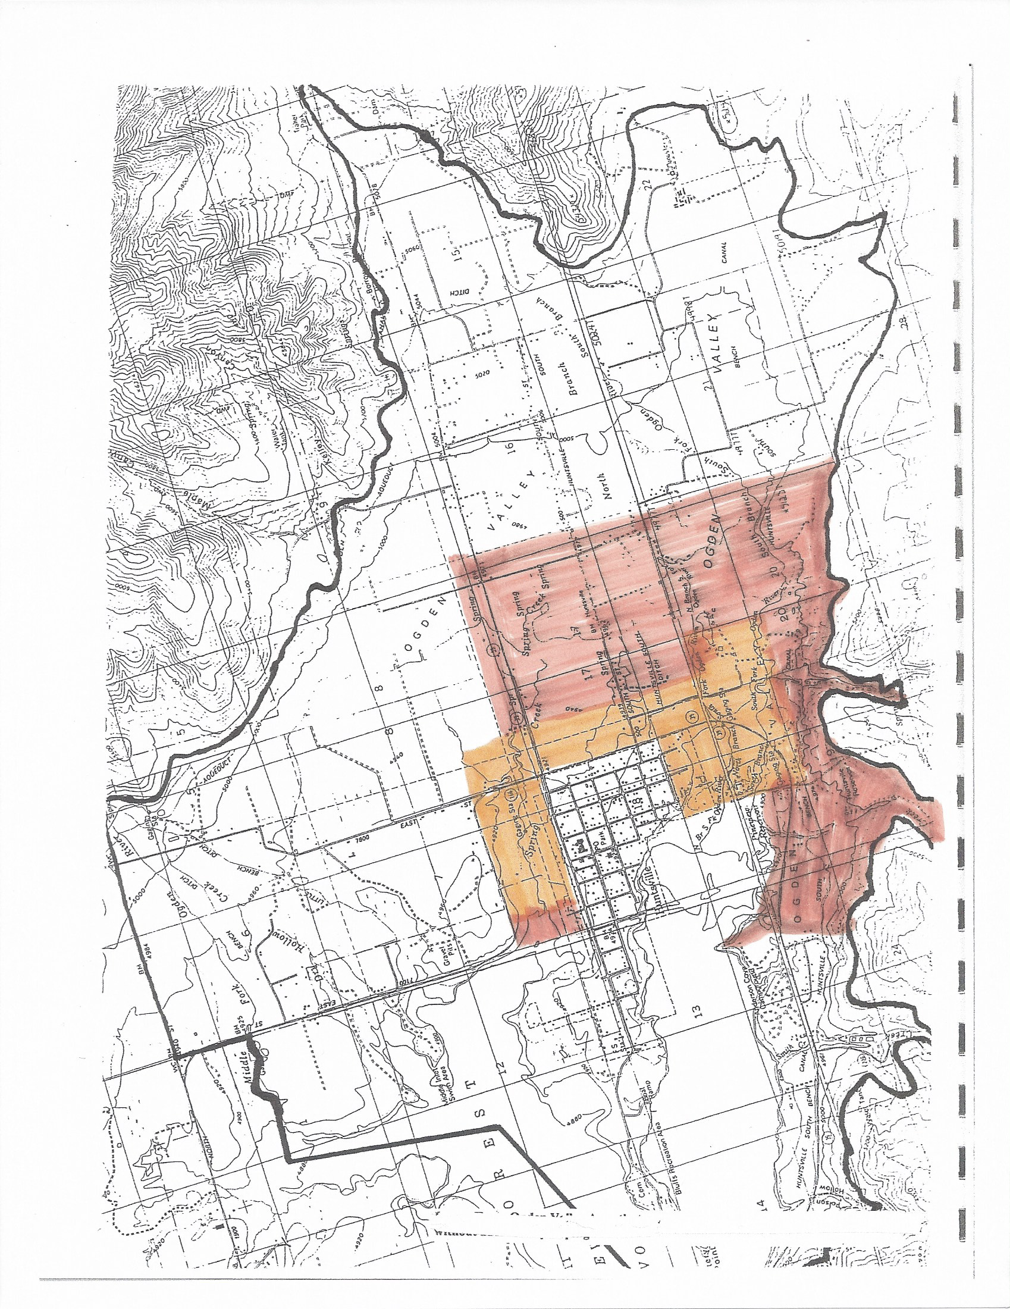
Figure Two – Annexation Proclamation depicting approximate land areas that might be considered for future annexation.

